Post-pandemic travel

Room 1: Lake Bled

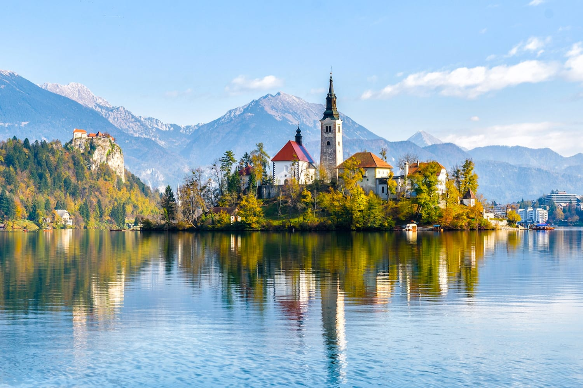

Try to find 5 pieces of information.

What are some of the things you can do in this area? http://www.lakebled.org

Does the accommodation seem expensive? https://www.booking.com/accommodation/city/si/bled.en-gb.html

Room 2: Kyoto

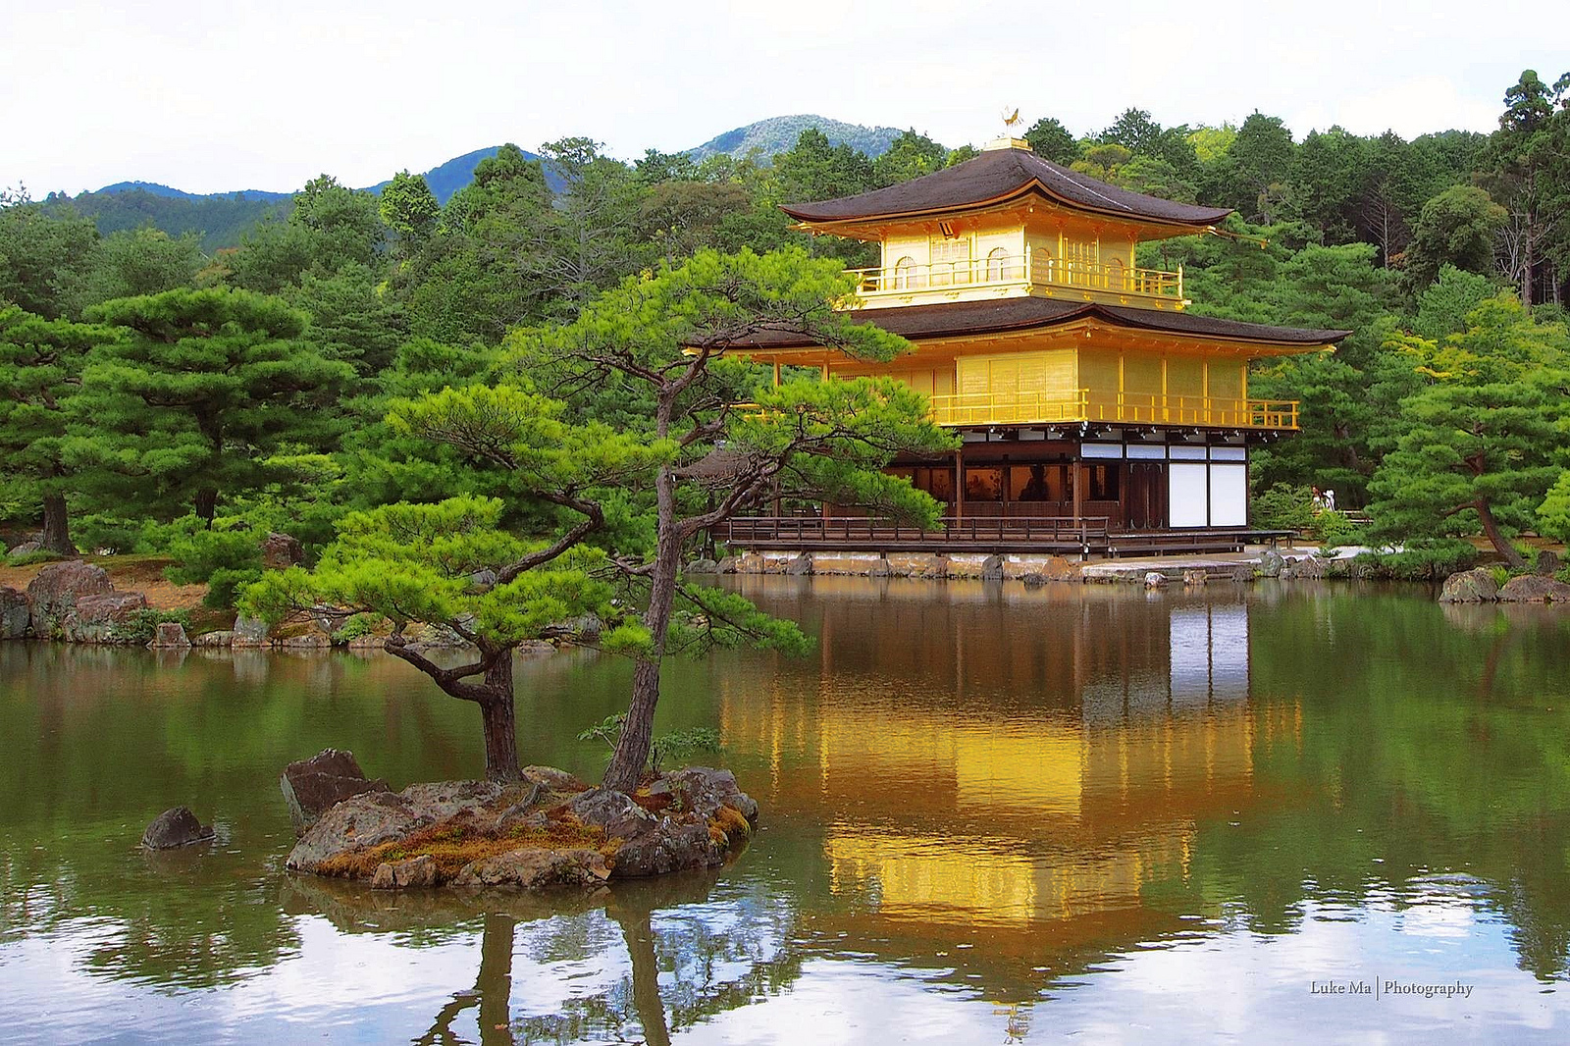

Try to find 5 pieces of information.

What is there to see and do? What is there to eat and drink? Does the accommodation seem expensive?

https://www.kayak.co.uk/Kyoto.20339.guide

Room 3: Marrakech

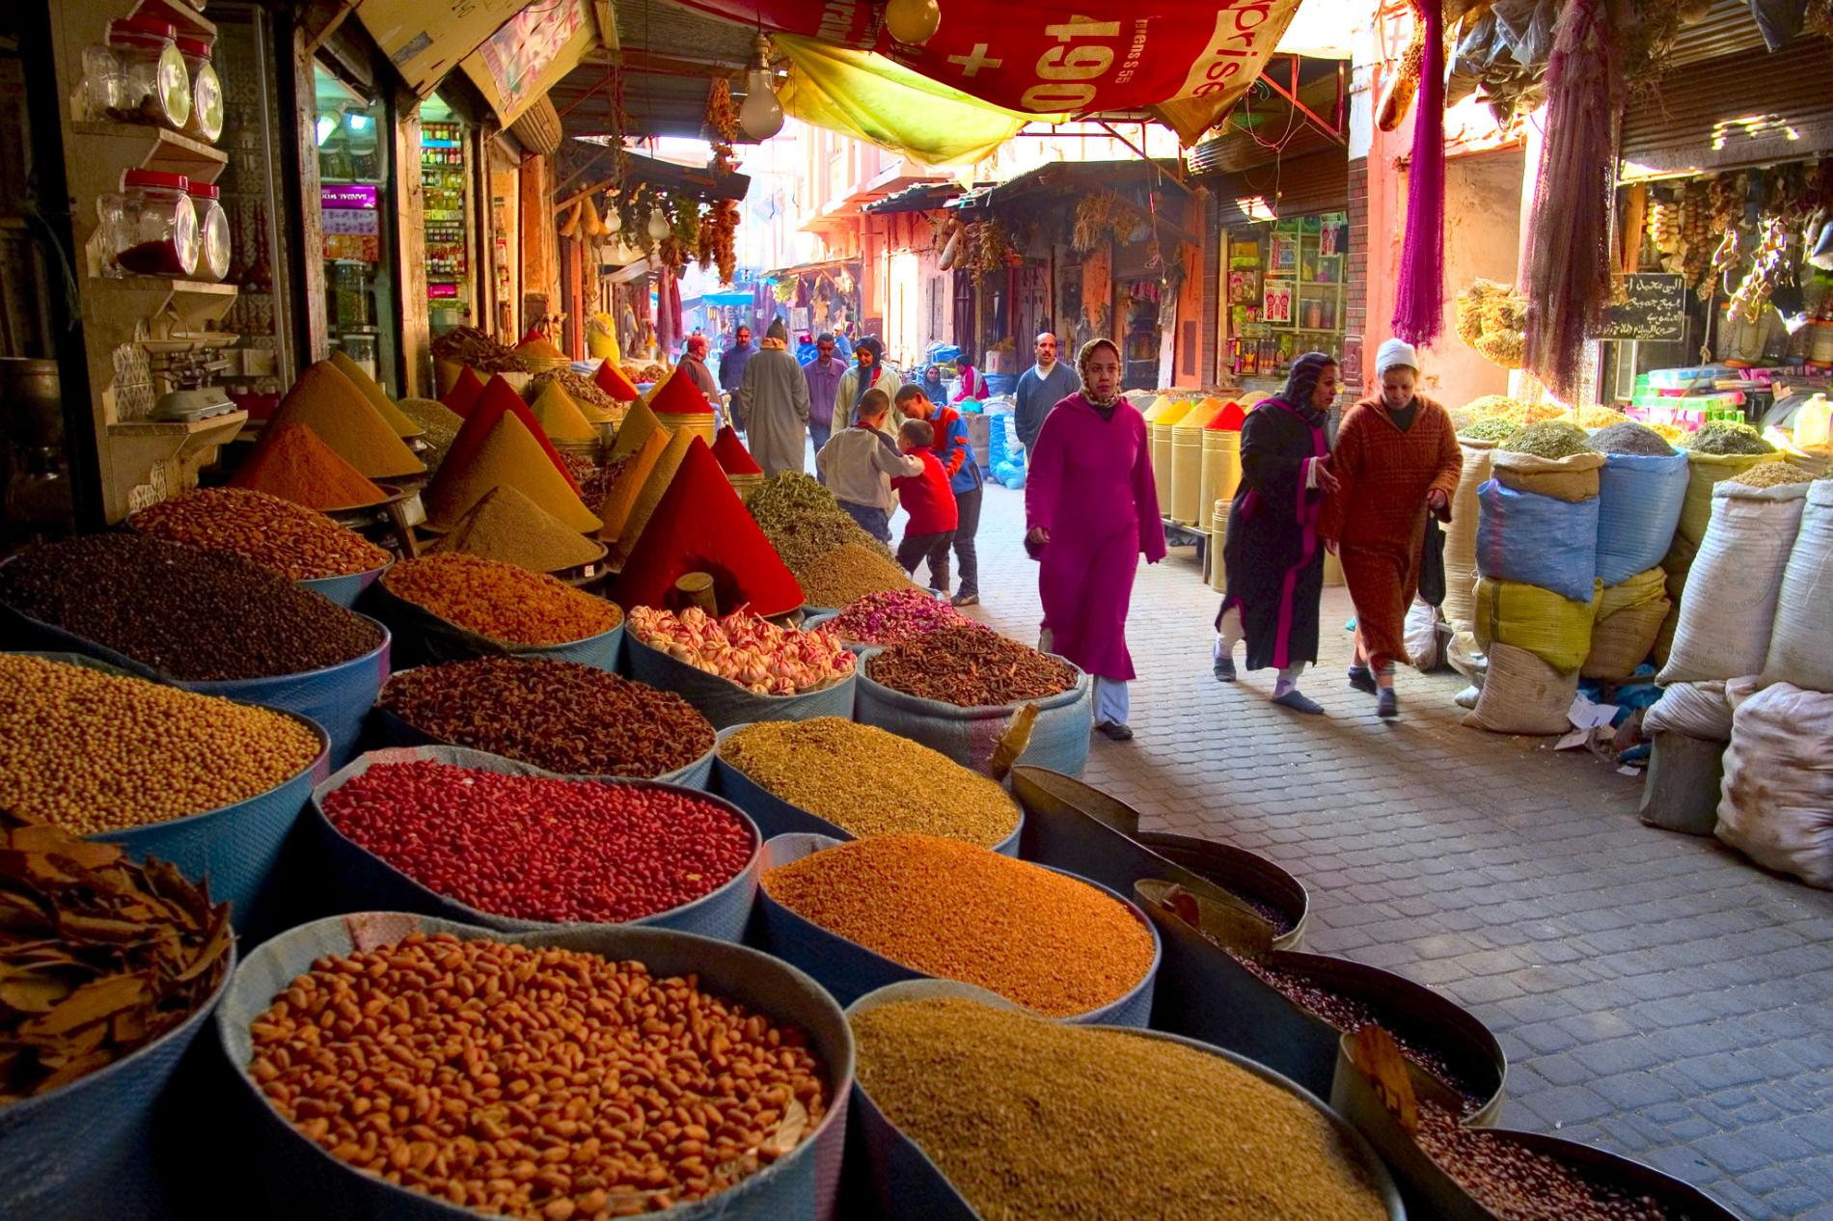

Try to find 5 pieces of information.

Is it easy to get to Marrakech? What is there to see and do there? What are the prices like there? Does the accommodation seem expensive?

https://www.kayak.co.uk/Marrakesh.26374.guide

