My dream festival line-up

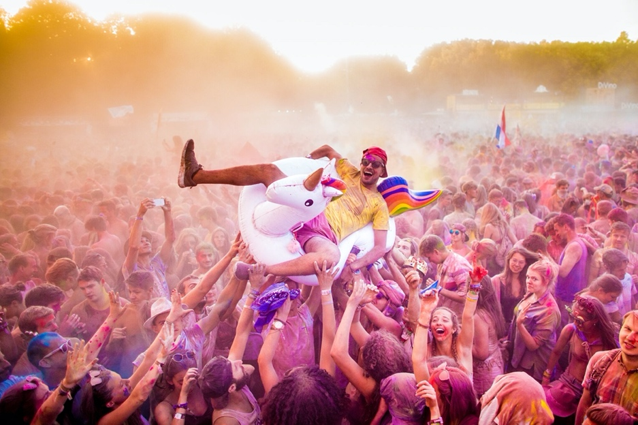

Which current bands/artists/performers would you like to see live?

Now write some notes about three you would like to book for the festival.

artist | because….

