File 4: Lonely Eels
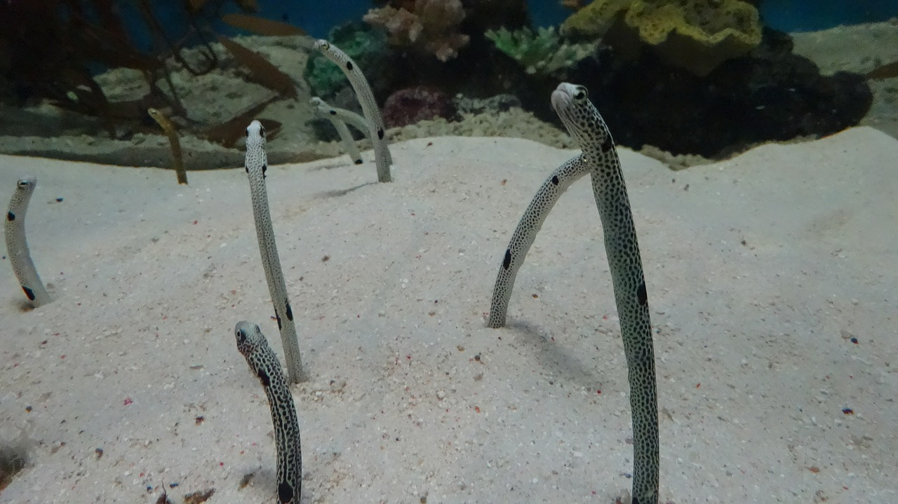

Staff at the Sumida Aquarium in Tokyo have asked the public for help - rather unusual help – to solve the problems of anxiety and social isolation that their spotted garden eels are currently experiencing. They have asked people from across the globe to video call the eels. But why? Due to the lockdown, the aquarium has been closed since the beginning of March, and so has had no visitors. Caretakers started to notice that when they approached the tanks where the eels live, the eels immediately buried themselves in the sand: it seemed they were becoming afraid of humans, due to lack of contact. This is problematic as it means the caretakers cannot properly check their health / look after them. The solution: a 3-day Zoom party to help the eels get used to humans again!

Real or Fake?

https://www.insider.com/facetime-an-eel-social-anxiety-japan-aquarium-2020-5

Real! Though the idea it was a 3-day Zoom party is an exaggeration…

Key information:

File 5: Monkey Riot
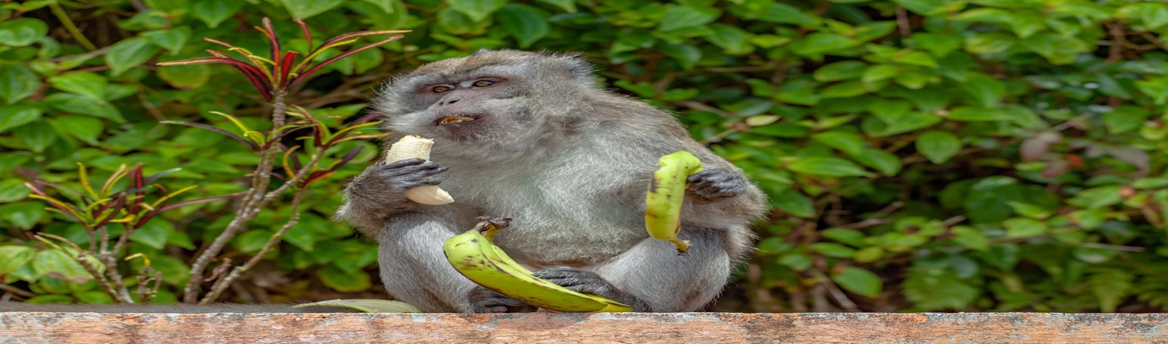

Lopburi, around 140 kms north of Bangkok, is well-known for its temples and its “Monkey Buffet Festival” in November; during this feast, local humans hope to bring good luck by feeding colourfully arranged fruit and vegetables to the local macaque monkeys. The monkeys are used to being fed by tourists all year, but with the lockdown in progress, there has been much less tourism, and therefore much less food for the macaques. This has led to “gang wars” with crowds of monkeys fighting in the streets over any food they can find. For instance, it was recently reported that dozens of the monkeys had left the temple where they live and wandered into the town, where a large fight started between the temple monkeys and the town monkeys after one of them discovered a pot of yoghurt.

Real or Fake?

https://www.livescience.com/macaque-fight-thailand-temple-coronavirus.html

Real! Click the link to see the video of the fight.

Key information:

File 6: The Handwashing Orangutan
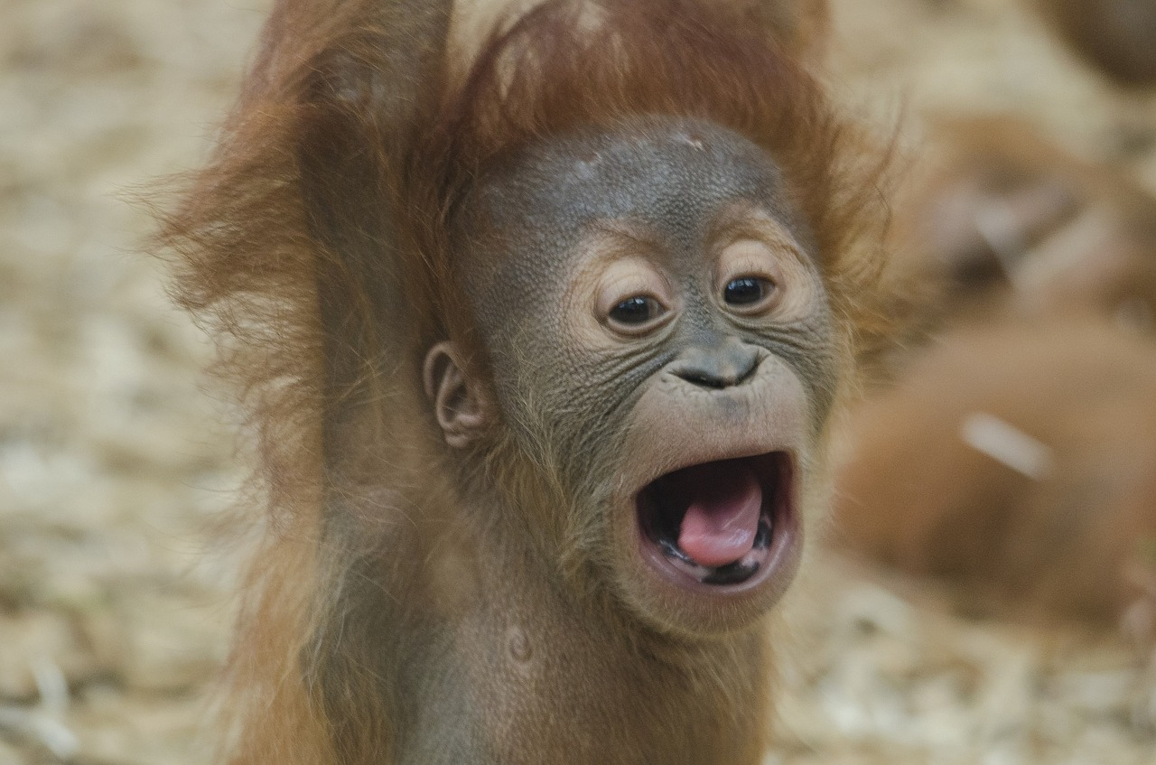

In April, a video appeared on social media, delighting hundreds. In the video, Sandra, an orangutan at the Center for Great Apes Sanctuary in Florida, washed her hands with soapy water; she had learned this gradually from watching the zookeepers wash their hands repeatedly due to the coronavirus. This led many to see Sandra as a “mascot” for hygiene during the pandemic, with users of social media noting that we should all behave like her, washing our hands for more than twenty seconds as she did. Sandra became the hero we didn’t know we needed.

Real or Fake?

https://www.snopes.com/fact-check/orangutan-handwashing-coronavirus/

Fake! The video released by the Center, playfully tweeted to encourage everyone to wash their hands, was filmed last year. She did not learn to wash her hands from watching the zookeepers. She simply enjoys washing things in soapy water.

Key information:

Questions for further discussion:

Did you believe any of the fake stories? Did you not believe any of the true stories? Why?
Which of the stories do you wish were true, and why?

Why have there been so many fake news stories in the last few years?

Why have there been so many fake news stories about animals during the pandemic?

Have you heard any other fake news stories in recent months?

What are the most harmful effects of fake news? Try to agree on 3 negative effects.

What can we do to help stop fake news from spreading / to stop people believing these stories?

